Smart restaurant

# Abstract

As technology grows in the world, everything needs to be done under the development of technology as well as to speed up and facilitate the daily personal work activities.

Smart restaurant is tedious job for restaurant with respect to time and workers. Providing a smart menu and automatic bills is very important process in any restaurant institution, this system helps to order foods and drinks using smartphone, tablet or computer, after ordering system provide bills automatically and provide way to pay without using cash, by using this system we will save our time and money and fight against diseaseS.

# Introduction

Smart Restaurant is the future of restaurant catalogs and order taking. It is easy to use application that replaces the old conventional restaurant catalog.

The application accessed on a smartphone, Tablet or computer, which replaces printed catalogues. Customers can browse through the offered products watching pictures and reading their description (e.g. ingredients, preparation procedures, even their nutrient value!).

# **Relevance**

**Overview of the project**

The computerized order and sales system can lessen the time consume in writing the order of the customer. In computerized order, the customer can select from the displayed menu in their owner tablet, smartphone or computer by scanning QR code attached on every table in the restaurant or access by typing URL of restaurant in the browser.

## Problem statement

* The traditional food ordering system is totally a manual process that includes pen, paper that leads to wastage of paper. The customers are always waiting for waiter to take the order that also consumes time. The waiters note-down the order from the customer. These orders provide to the kitchen department, update them in records and again make the manual bills.
* Every client touch to the menu catalogs which can cause spread of some diseases such as Covid-19
* This system is very simple, but it includes the errors while note down the orders and also making the calculations. It is sometimes difficult to translate the handwriting of waiter

## Objectives

The objectives of this project are divided into general objectives and specific objectives all aiming to benefit restaurants when they want to increase quality of services and became famous.

### General Objectives

This study aims to design and construct a “Computer-Based Ordering System”, to provide an easy access in getting their orders and verifying their bills.

### Specific Objectives

To develop the software program using Hyper Text Mark-up Language (HTML) that will be used for the transaction.

To create a more convenient from of ordering and verification system in fast-food restaurants and the like.

To lessen the work of waiters in assisting the customers.

## Scope and Limitation

This system will be limited to a small and medium restaurants and bars which does not require much networking devices to host our system, means it is easy to deploy (system is ready for productive work in a live in small and medium environment.)

## System requirements

## Proposed solution

* System will solve food ordering system is totally a manual process to automatic that reduce wastage of paper by replacing it with smart device like smartphone, tablet, computer etc. The customers will no longer wait waiter to take the order. In this system, customers give their order through the system and directly stored to database, these orders provide to the kitchen department, update them in records and again make the automatic bills.
* This system is very simple, because it will reduce the errors of note down the orders and making the calculations and display total price automatically as a user order foods and drinks.

## Report and organization

**Impact to community**

* Restaurants become famous when use technology modern system
* Reduce number of payment for employee
* Improved restaurants standard service
* Guarantee of customer comfortability
* Make customers more interested
* Gain profit
* Reduce spread of diseases

**Business model**

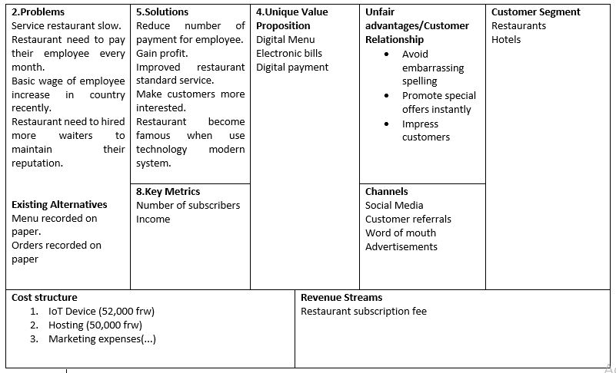

**Research methodology**

Survey

Case study

Interview